Binary coding an analog Signal by Sampling, Quantizing and Encoding

SHARMI R   
*Department of ECE*  
*Self-employed*Tamil Nadu, Country  
sharmir08@gmail.com

*Abstract*— Sampling, Quantization, Encoding is an important step in Digital Modulation. This paper shows the mixed signal implementation of encoding an analog signal using sampling and hold circuit followed by a Flash Type ADC which is implemented using Op-amp. The sample and hold circuits samples the incoming analog signals and the hold circuits help us to determine the signal voltage level and the sampled instant (Quantizing) and the Flash type ADC is used to convert the Quantized value into Binary encoded signal.

Keywords — Flash Type ADC, Sample and Hold circuit, Op-amp, Quantization, Sampling

# Reference circuit details

Figure (1) shows the circuit of two voltage followers, the first voltage follower is connected to the analog input signal to be sampled. The n-channel MOSFET acts as a switch sampling the signal only at the control voltage, which is applied to the Gate terminal of MOSFET. The sampling frequency is equal to the frequency of the control voltage. When the Switch i.e. the MOSFET is ON, the capacitor charges to the level of the input signal voltage and when the MOSFET is OFF the capacitor holds the value for a specific time. The time period over which the capacitor holds the input voltage is called Sample Period. The frequency of the control voltage must satisfy Nyquist criteria for sampling frequency. The first voltage follower is used to prevent the loading of input source and the second voltage follower is used to prevent loading of capacitor C.

Figure (2) shows the circuit of the flash type ADC which converts the incoming sampled and quantized signal into 3 bit binary values. Flash type ADC is also known as Parallel ADC, which is one of the fastest ADC. Based on the range of Voltage level of the input signal, Vo, the Priority encoder will produce the corresponding digital value.

Figure (3) shows the waveforms of the circuits shown. The analog input is Vi which is sampled using the control voltage/ sampling voltage provided by the sample and hold circuit. This sampled waveform is encoded into binary based on the voltage of the sampled signal.

# Reference circuit design

‌‌

‌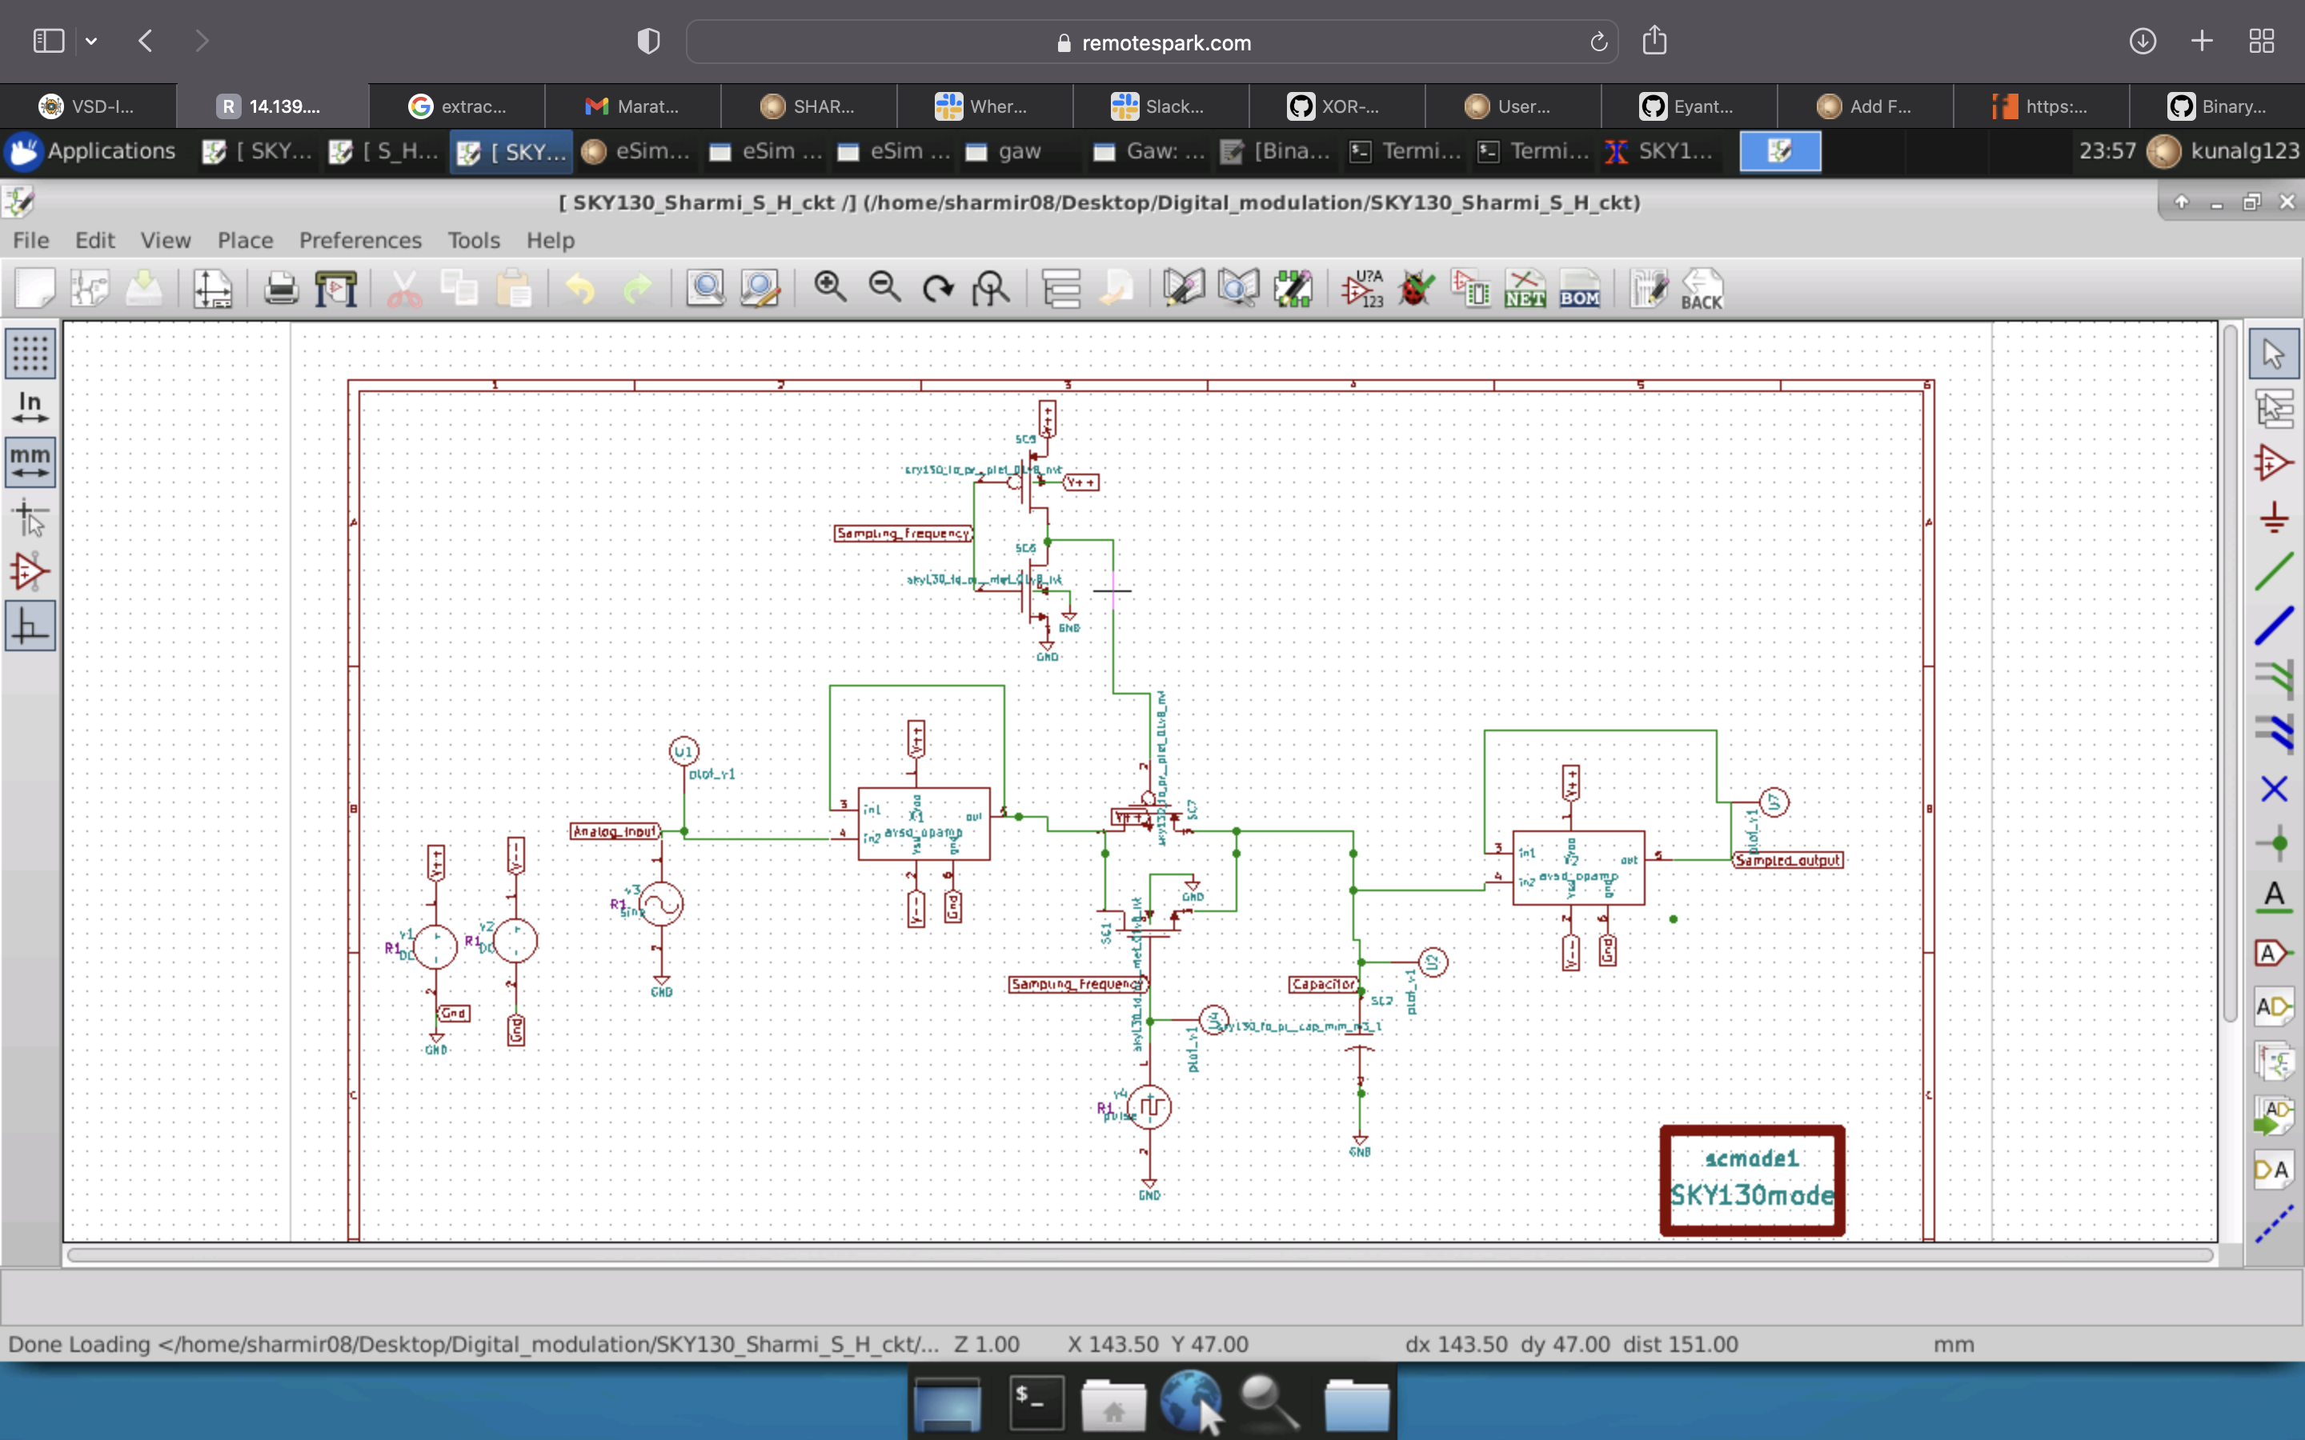

‌

1. Sample and Hold Circuit using Op-amp

# 

1. Flash type ADC with a priority encoder

# Reference waveforms

1. Reference output waveform for the above circuits

##### References

1. G Akash Ambekar, “Implementation of High Speed 3- bit Flash type Analog to Digital converter(ADC),” Issue 1, Version 1, 2022
2. Sumanyu Singh, “Design of 3 bit Flash Type ADC”, <https://github.com/Sumanyu-Singh/Mixed-Signal-Design-of-3-bit-flash-Type-ADC>
3. https://github.com/Sharmi-Rajakumaran/Binary_Coding_an_Analog_Signal/blob/main/README.md